­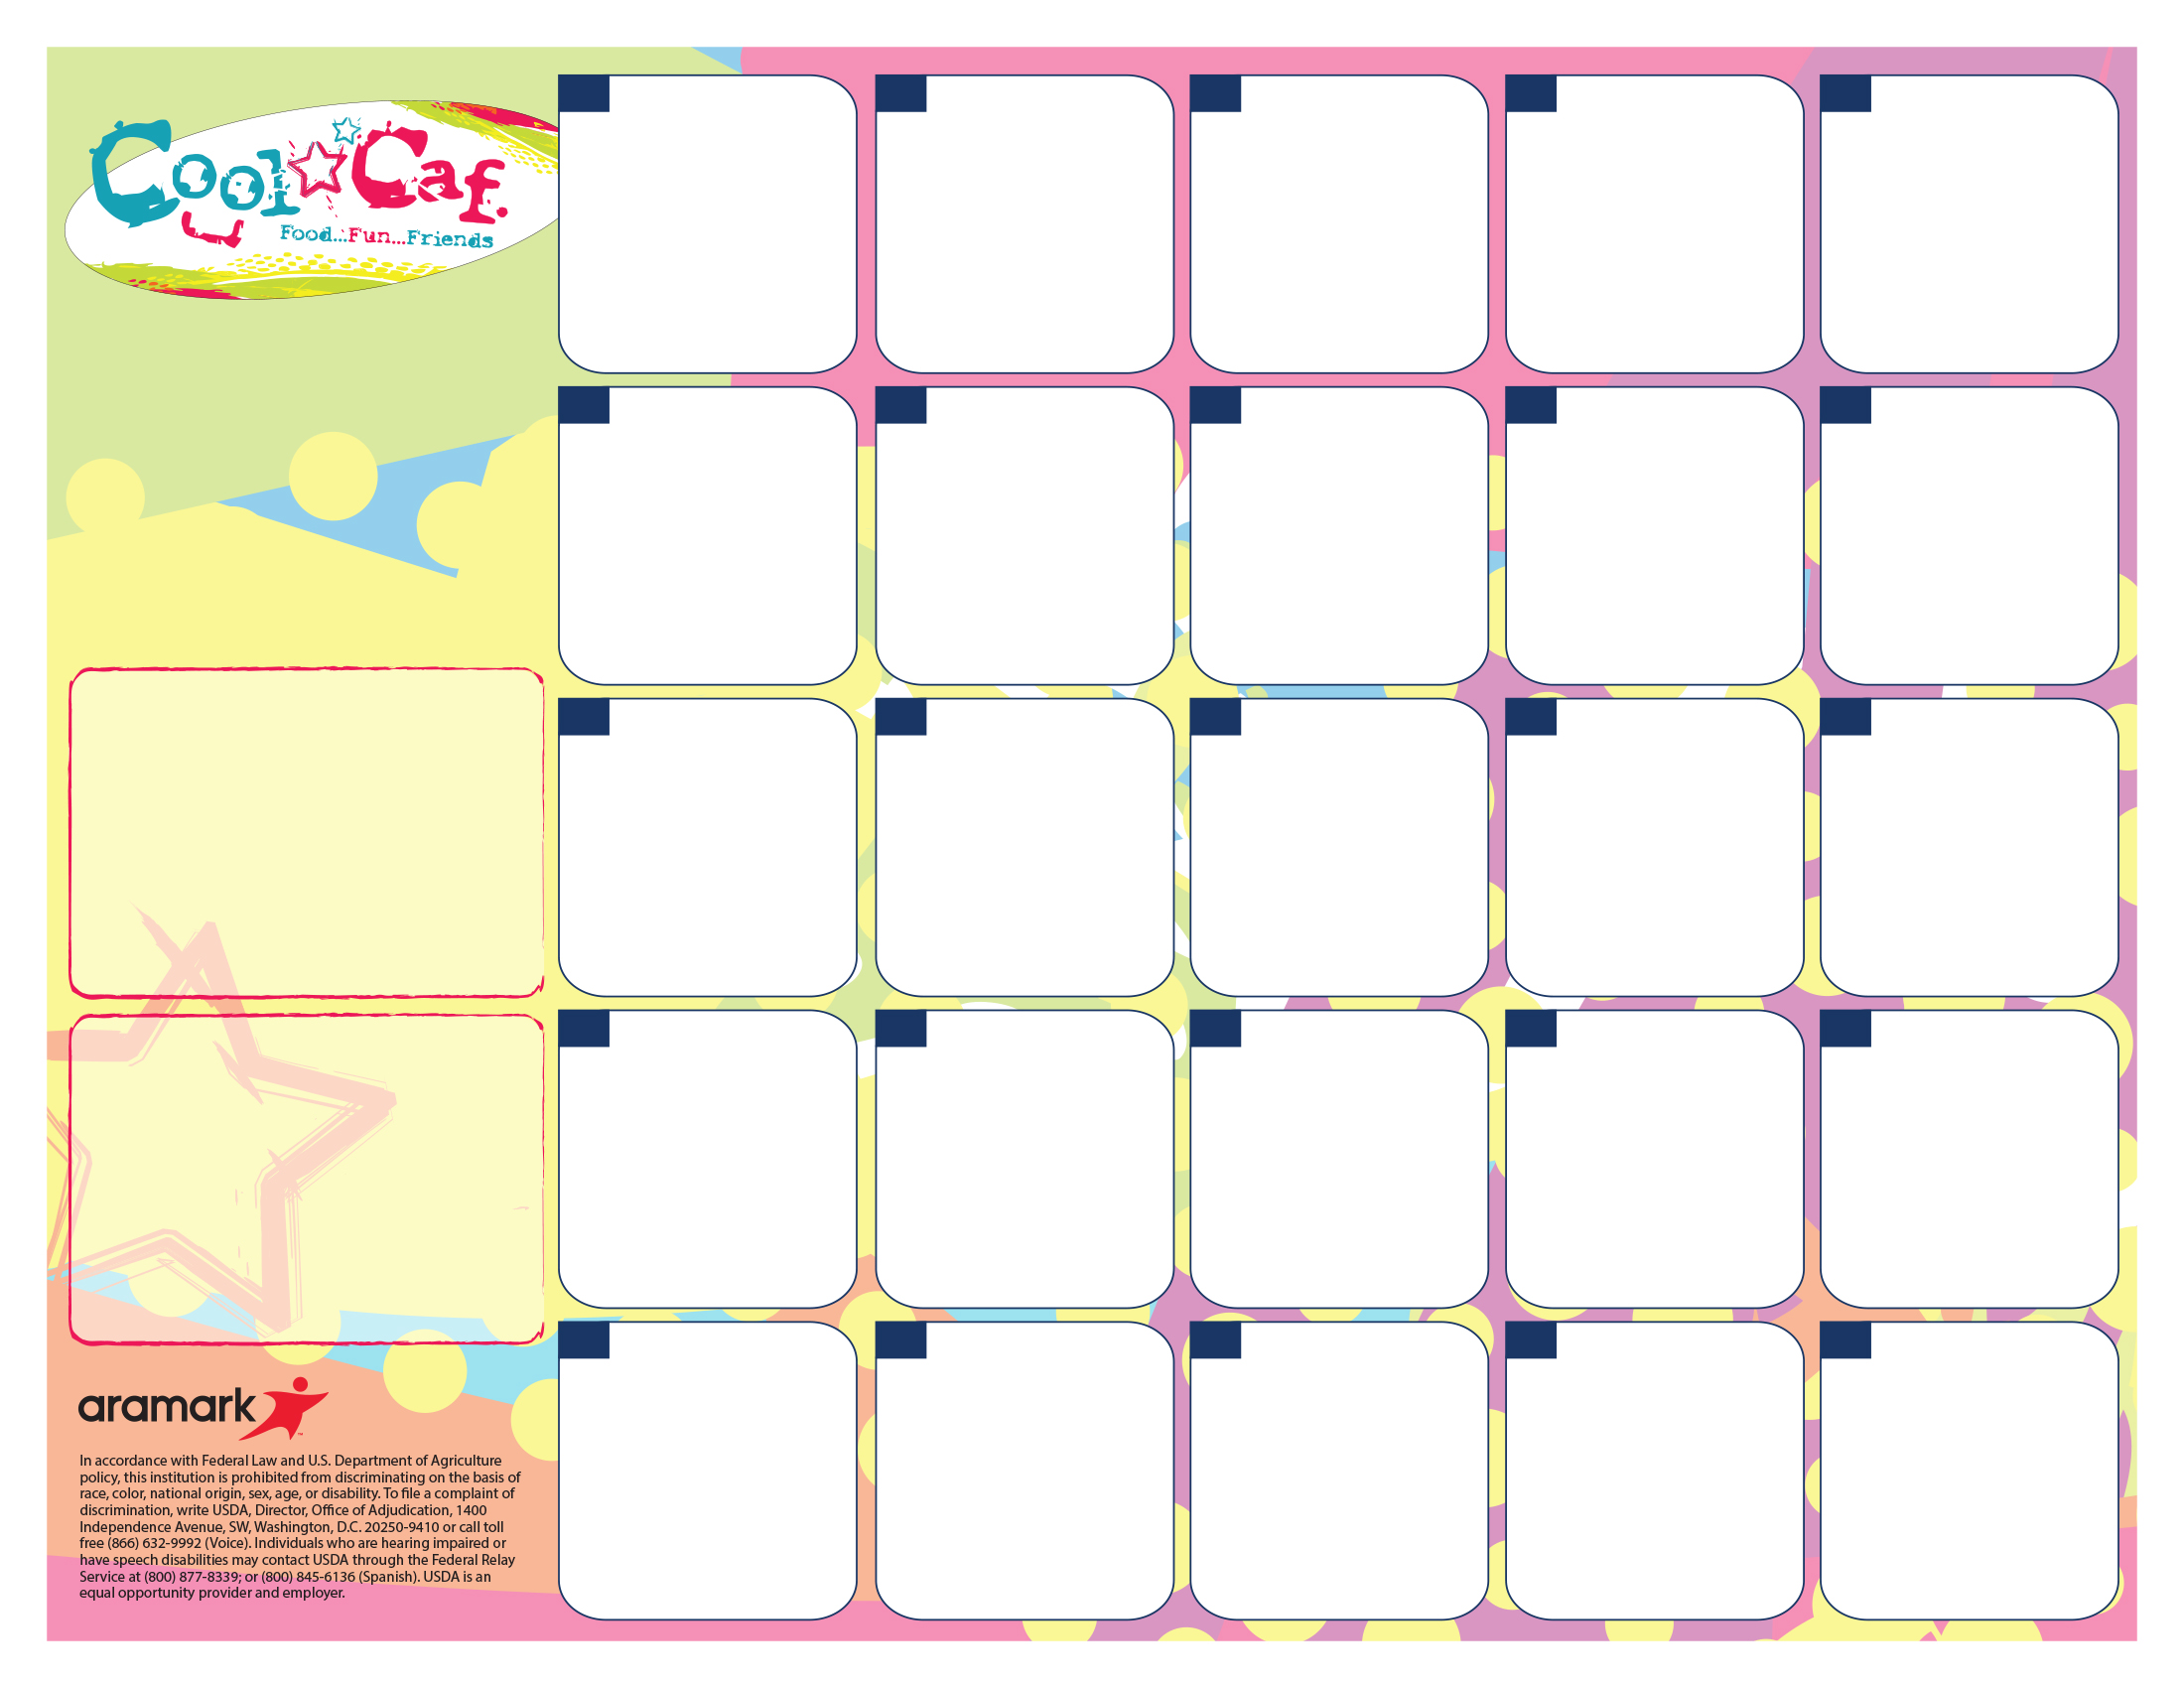

A. Nachos

B. Chicken Sandwich

C. Healthy Choice

D. PB&J

Refried Beans

Fruit & Veggie Bar

**Thanksgiving Lunch**

Turkey

Mashed Potatoes & Gravy w/roll.

Stuffing

Corn

Cookie

**21**

A. Variety Pizza

B. Chicken Sandwich

C. Healthy Choice

D. PB&J

Corn

Fruit & Veggie Bar

**20**

A. Chicken Patty Sandwich

B. Ham and Cheese on Bun

C. Healthy Choice

D. PB&J

Fruit & Veggie Bar

***Pre order on the 13th***

**14**

**No**

**School**

**28**

**31**

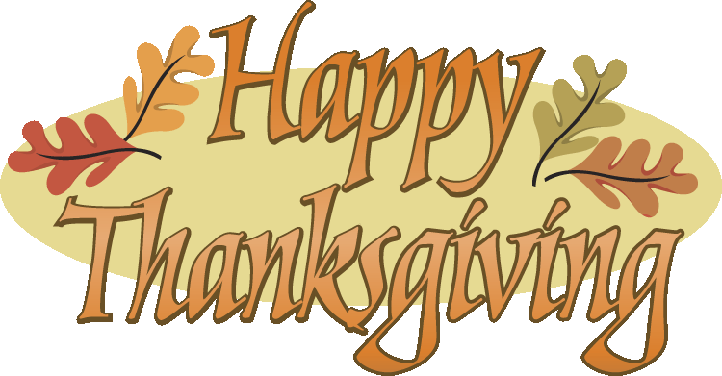

A. Omelet w/cinnamon roll

B. Pretzel w/cheese

C. Healthy Choice

D. PB&J

Hash brown

Fruit & Veggie Bar

**4**

**LUNCH PRICES!**

Lunch

K-5th $2.35

6-8th $2.60

Reduced $.40

Milk/Juice Ala Carte $.50

**Fat free milk, low fat milk, or 100% juice included with each meal.**

A. Chicken Nuggets

B. Boscos

C. Healthy Choice

D. PB&J

French Fries

Fruit & Veggie Bar

**19**

A. Rotini & Meat sauce w/garlic toast

B. Pretzel w/cheese

C. Healthy Choice

D. PB&J

Broccoli

Fruit &Veggie Bar

**Pudding Giveaway**

**7**

**No**

**School**

***29***

**22**

A. Chili Cheese Dog

B. Pizza

C. Healthy Choice

D. PB&J

Tater Tots

Fruit & Veggie Bar

**1**

A. Grilled Cheese & Soup

B. Corndog

C. Healthy Choice

D. PB&J

Green Beans

Fruit & Veggie Bar

**15**

A. Chicken Nuggets

B. Pretzel w/cheese

C. Healthy Choice

D. PB&J

Mashed Potatoes & Gravy W/Roll

Fruit & Veggie Bar

**5**

**1**

A. Popcorn Chicken

B. Pizza

C. Healthy Choice

D. PB&J

French Fries

Fruit & Veggie Bar

**26**

A. BBQ Meatballs

B. Pretzel w/cheese

C. Healthy Choice

D. PB&J

Scallop Potatoes

Fruit & Veggie Bar

**8**

**=**

A. Variety Pizza

B. Corndog

C. Healthy Choice

D. PB&J

Corn

Fruit & Veggie Bar

***Pre order for the 14th***

**13**

A. Confetti Pancakes W/sausage

B. Pizza

C. Healthy Choice

D. PB&J

Hash brown

Fruit & Veggie Bar

**25**

A. Scrambled Eggs with biscuit & Gray

B. Chicken Sandwich

C. Healthy Choice

D. PB&J

Broccoli

Fruit & Veggie Bar

**18**

A. Chicken Tenders

B. Corndog

C. Healthy Choice

D. PB&J

Mashed Potatoes & Gravy W/Roll

Fruit & Veggie Bar

**12**

Enjoy Your Break

See You Jan 7th

**27**

A. Variety Pizza

B. Pretzel w/cheese

C. Healthy Choice

D. PB&J

Corn

Fruit & Veggie Bar

**6**

A. Waffle Bar & Sausage Patty

B. Corndog

C. Healthy Choice

D. PB&J

Hash brown

Fruit & Veggie Bar

**11**

Go to [www.sendmoneytoschool.com](http://www.sendmoneytoschool.com) to view or deposit money to your child’s account.

Go to:

[**www.lunchapp.com**](http://www.lunchapp.com) to apply for Free/Reduced Meals.

**Dutton Christian South Campus Lunch Menu**

**November 2019**