­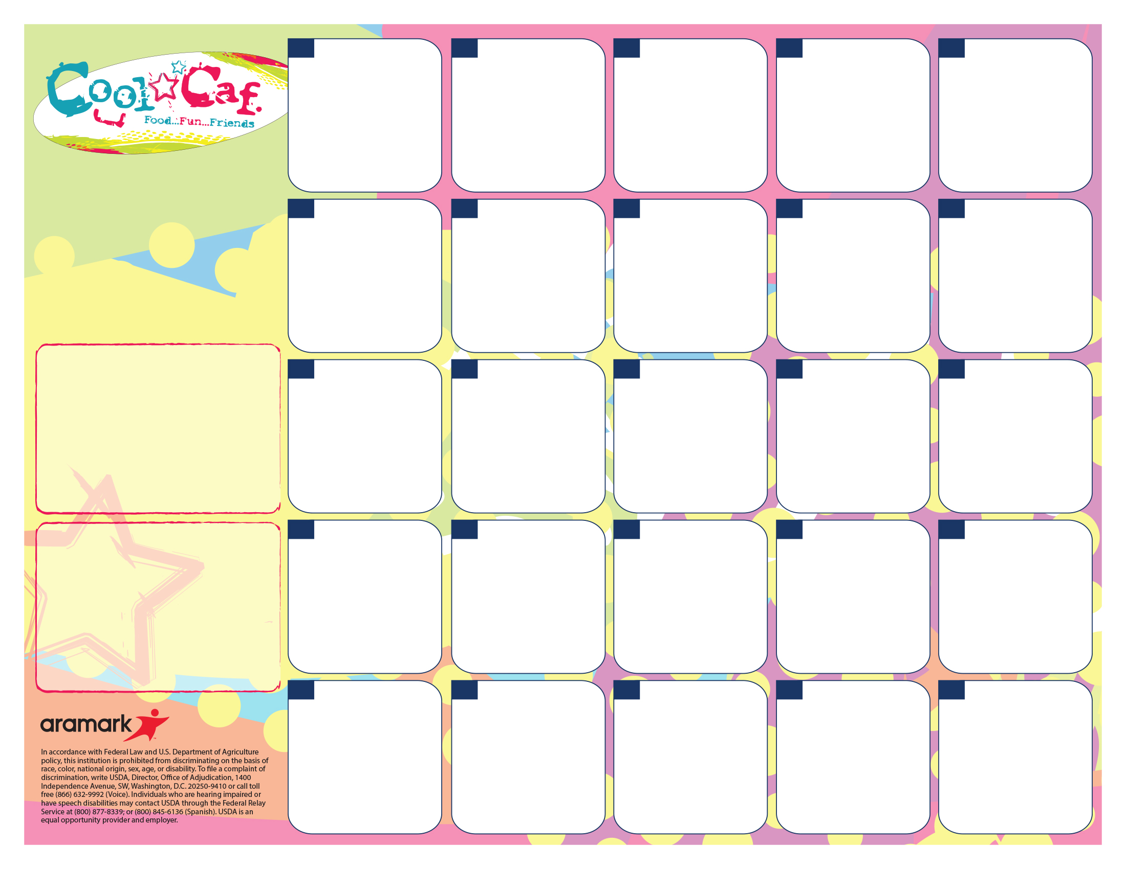

A. Chicken Sandwich

B. Ham & Cheese on Bun

C. Healthy Choice

D. PB&J

Fruit & Veggie Bar

**Pre Order on the 30th**

A. Potion Pizza

B. Crow Corn Dog

C. Haunted Healthy Choice

D. Pirate PB&J

Creepy Corn

Frightful Fruit & Veggie Bar

**Pre Order for the 31st.**

**31**

**31**

**New Item**

A. Omlete w/cinnamon roll

B. Pretzel w/cheese

C. Healthy Choice

D. PB&J

Hash brown

Fruit & Veggie Bar

**7**

A. Rotini & Meat sauce

B. Boscos

C. Healthy Choice

D. PB&J

Green Beans

Fruit & Veggie Bar

**3**

**No**

**School**

**23**

**No**

**School**

**24**

**No**

**School**

**LUNCH PRICES!**

Lunch

K-5th $2.35

6-8th $2.60

Reduced $.40

Milk/Juice Ala Carte $.50

**Fat free milk, low fat milk, or 100% juice included with each meal.**

A. Chicken Nuggets

B. Chicken Sandwich

C. Healthy Choice

D. PB&J

Mashed Potatoes & Gravy W/Roll

Fruit & Veggie Bar

**22**

A. Walking Taco

B. Corndog

C. Healthy Choice

D. PB&J

Refried Beans

Fruit & Veggie Bar

**17**

A. Mac N Cheese & Garlic Toast

B. Pretzel w/cheese

C. Healthy Choice

D. PB&J

Broccoli

Fruit &Veggie Bar

**Pudding Giveaway**

**10**

**25**

A. Chili Cheese Dog

B. Boscos

C. Healthy Choice

D. PB&J

Tater Tots

Fruit & Veggie Bar

**4**

A. Penne W/Alfredo Sauce & Garlic Toast

B. Corndog

C. Healthy Choice

D. PB&J

Green Beans

Fruit & Veggie Bar

**18**

A. Popcorn Chicken

B. Pretzel w/cheese

C. Healthy Choice

D. PB&J

Mashed Potatoes & Gravy W/Roll

Fruit & Veggie Bar

**8**

**1**

A. Popcorn Chicken

B. Pizza

C. Healthy Choice

D. PB&J

French Fries

Fruit & Veggie Bar

**29**

A. Chicken Parm Sandwich

B. Pretzel w/cheese

C. Healthy Choice

D. PB&J

Green Beans

Fruit & Veggie Bar

**11**

**=**

A. Big Daddy Pizza

B. Corndog

C. Healthy Choice

D. PB&J

Corn

Fruit & Veggie Bar

**16**

**New Item**

A. Confetti Pancakes W/sausage

B. Pizza

C. Healthy Choice

D. PB&J

Hash brown

Fruit & Veggie Bar

**28**

A. Pretzel w/Cheese

B. Chicken Sandwich

C. Healthy Choice

D. PB&J

Broccoli

Fruit & Veggie Bar

**21**

A. Chicken Tenders

B. Corndog

C. Healthy Choice

D. PB&J

Mashed Potatoes & Gravy W/Roll

Fruit & Veggie Bar

**15**

A. Big Daddy Pizza

B. Boscos

C. Healthy Choice

D. PB&J

Corn

Fruit & Veggie Bar

**Cookie Giveaway**

**2**

A. Chicken Drumstick

B. Boscos

C. Healthy Choice

D. PB&J

Mashed Potatoes & Gravy & Roll

Fruit & Veggie Bar

**1**

Enjoy Your Break

See You Jan 7th

**30**

A. French Bread Pizza

B. Pretzel w/cheese

C. Healthy Choice

D. PB&J

Corn

Fruit & Veggie Bar

**9**

A. Waffle Bar & Sausage Patty

B. Corndog

C. Healthy Choice

D. PB&J

Hash brown

Fruit & Veggie Bar

**14**

Go to [www.sendmoneytoschool.com](http://www.sendmoneytoschool.com) to view or deposit money to your child’s account.

Go to:

[**www.lunchapp.com**](http://www.lunchapp.com) to apply for Free/Reduced Meals.

**Dutton Christian North Campus Lunch Menu**

**October 2019**