­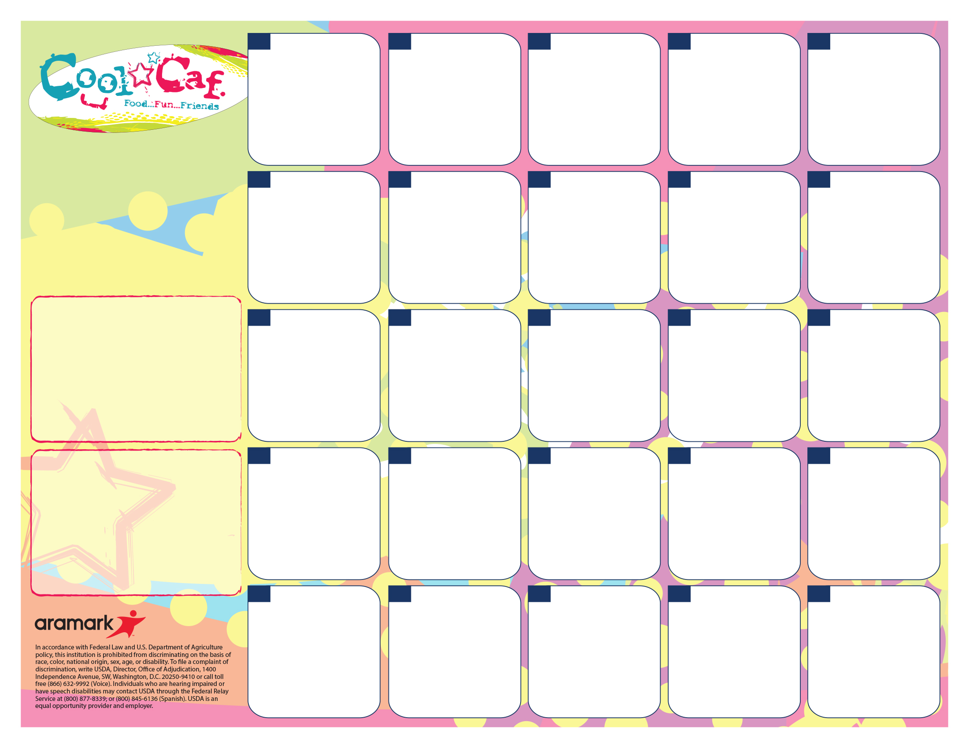

A. Rotini W/Meat Sauce

B. Crispitos

C. Healthy Choice

D. PB&J

Green Beans

Fruit & Veggie Bar

A. Tony’s Pizza

B. Crispitos

C. Healthy Choice

D. PB&J

Corn

Fruit & Veggie Bar

**31**

**31**

A. Chicken Fries

B. Crispitos

C. Healthy Choice

D. PB&J

Mashed Potatoes & Gravy W/Roll

Fruit & Veggie Bar

**29**

A. Scrambled Eggs & Cinnamon Roll

B. Crispitos

C. Healthy Choice

D. PB&J

Hash Brown

Fruit & Veggie Bar

**M&M Giveaway**

**28**

A. Ravioli & Garlic Biscuit

B. Pizza

C. Healthy Choice

D. PB&J

Broccoli

Fruit & Veggie Bar

**24**

A. Chicken Patty Sandwich

B. Ham & Cheese Sandwich

C. Healthy Choice

D. PB&J

Fruit &Veggie Bar

***Pre order on the 22nd***

**23**

A. Waffle Bar W/ Sausage Patty

B. Pizza

C. Healthy Choice

D. PB&J

Hash Brown

Fruit & Veggie Bar

**21**

A. Hamburger or Cheeseburger

B. Corn Dog

C. Healthy Choice

D. PB&J

French Fries

Fruit & Veggie Bar

**18**

A. Walking Taco

B. Corn Dog

C. Healthy Choice

D. PB&J

Refried Beans

Fruit & Veggie Bar

**17**

A. Chicken Nuggets

B. Corn Dog

C. Healthy Choice

D. PB&J

Mashed Potatoes & Gravy W/Roll

Fruit & Veggie Bar

**15**

**No**

**School**

**5**

**No**

**School**

**4**

**No**

**School**

**3**

**No**

**School**

**1**

Enjoy Your Break

See You Jan 7th

**30**

A. French Bread Pizza

B. Corn Dog

C. Healthy Choice

D. PB&J

Corn

Fruit & Veggie Bar

**Cookie Giveaway**

**16**

A. King Size Pretzel with Cheese Sauce

B. Boscos

C. Healthy Choice

D. PB&J

Veggie Blend

Fruit & Veggie Bar

**11**

**=**

A. Mini Pancakes with Sausage

B. Boscos

C. Healthy Choice

D. PB&J

Hash Brown

Fruit & Veggie Bar

**7**

A. Grilled Cheese & Soup

B. Pizza

C. Healthy Choice

D. PB&J

Green Beans

Fruit & Veggie Bar

**2525**

A. Big Daddy Pizza

B. Boscos

C. Healthy Choice

D. PB&J

Green Beans

Fruit & Veggie Bar

**Pudding Giveaway**

**9**

A. Mac N Cheese W/Garlic Toast

B. Boscos

C. Healthy Choice

D. PB&J

Broccoli

Fruit & Veggie Bar

**10**

***No Fees In***

***January!!***

***Go to:***

***Sendmoneytoschool.com***

A. Chicken Patty Sandwich

B. Corn Dog

C. Healthy Choice

D. PB&J

Tater Tots

Fruit & Veggie Bar

**14**

A. Chicken Drumstick

B. Pizza

C. Healthy Choice

D. PB&J  
Mashed Potatoes & Gravy W/Roll

Fruit & Veggie Bar

***Pre order for the 23rd***

**22**

A. Popcorn Chicken

B. Boscos

C. Healthy Choice

D. PB&J

Mashed Potatoes & Gravy W/Roll

Fruit & Veggie Bar

**8**

**1**

**LUNCH PRICES!**

Lunch $2.30

Reduced $.40

Milk/Juice Ala Carte $.50

**Fat free milk, low fat milk, or 100% juice included with each meal.**

Go to [www.sendmoneytoschool.com](http://www.sendmoneytoschool.com) to view or deposit money to your child’s account.

Go to:

[**www.lunchapp.com**](http://www.lunchapp.com) to apply for Free/Reduced Meals.

**Dutton Christian South Campus Lunch Menu**

**January 2019**